COLLEGE CODE : 6208

NAME : BARANI.G

IBM REG NO : au620821106012

PROJECT NAME : PREDICTION HOUSE PRICE USING MACHINE LEARNING

Phase 3: Development Part 1

Topic : Start building the house price prediction model by loading and pre-processing the dataset.

HOUSE PRICE PREDICTION

INTRODUCTION:

* This introduction will guide you through the initial steps of the process. We'll explore how to import essential libraries, load the housing dataset, and perform critical preprocessing steps. Data preprocessing is crucial as it helps clean, format, and prepare the data for further analysis. This includes handling missing values, encoding categorical variables, and ensuring that the data is appropriately scaled.

* Building a house price prediction model is a data-driven process that involves harnessing the power of machine learning to analyse historical housing data and make informed price predictions. This journey begins with the fundamental steps of data loading and preprocessing.

**1**.**Import Libraries:**

Start by importing the necessary libraries:

**Program:**

import pandas as pd

import numpy as np

from sklearn.model_selection import train_test_split

from sklearn.preprocessing import StandardScaler

**2.Load the Dataset**:

Load your dataset into a Pandas DataFrame. You can typically find house price datasets in CSV format, but you can adapt this code to other formats as needed.

**Program:**

df = pd.read_csv(' E:\USA_Housing.csv ')

Pd.read()

**3. Exploratory Data Analysis (EDA):**

Perform EDA to understand your data better. This includes checking for missing values, exploring the data's statistics, and visualizing it to identify patterns.

**Program:**

# Check for missing values

print(df.isnull().sum())

# Explore statistics

print(df.describe())

# Visualize the data (e.g., histograms, scatter plots, etc.)

**4. Feature Engineering:**

Depending on your dataset, you may need to create new features or transform existing ones. This can involve one-hot encoding categorical variables, handling date/time data, or scaling numerical features.

**Program:**

# Example: One-hot encoding for categorical variables

df = pd.get_dummies(df, columns=[' Avg. Area Income ', ' Avg.

Area House Age '])

**5. Split the Data:**

Split your dataset into training and testing sets. This helps you

Evaluate your model's performance later.

X = df.drop('price', axis=1) # Features

y = df['price'] # Target variable

X_train, X_test, y_train, y_test = train_test_split(X, y, test_size=0.2,random_state=42)

**6. Feature Scaling:**

Apply feature scaling to normalize your data, ensuring that all

features have similar scales. Standardization (scaling to

mean=0 and std=1) is a common choice.

**Program:**

scaler = StandardScaler()

X_train = scaler.fit_transform(X_train)

X_test = scaler.transform(X_test)

**Challenges involved in loading and preprocessing a house price dataset;**

There are a number of challenges involved in loading and preprocessing a house price dataset, including:

* **Handling missing values:**

House price datasets often contain missing values, which can be due to a variety of factors, such as human error or incomplete data collection. Common methods for handling missing values include dropping the rows with missing values, imputing the missing values with the mean or median of the feature, or using a more sophisticated method such as multiple imputation.

* **Encoding categorical variables:**

House price datasets often contain categorical features, such as the type of house, the neighborhood, and the school district. These features need to be encoded before they can be used by machine learning models. One common way to encode categorical variables is to use one-hot encoding.

* **Scaling the features:**

It is often helpful to scale the features before training a

machine learning model. This can help to improve the performance of the model and make it more robust to outliers. There are a variety of ways to scale the features, such as min-max scaling and standard scaling.

* **Splitting the dataset into training and testing sets:**

Once the data has been pre-processed, we need to split the dataset into training and testing sets. The training set will be used to train the model, and the testing set will be used to evaluate the performance o the model on unseen data. It is important to split the dataset in a way that is representative of the real world distribution of the data.

**How to overcome the challenges of loading and preprocessing a house price dataset:**

There are a number of things that can be done to overcome the challenges of loading and preprocessing a house price dataset, including:

* **Carefully consider the specific needs of your mode:**

The best way to preprocess the data will depend on the specific machine learning algorithm that you are using. It is important to carefully consider the requirements of the algorithm and to preprocess the data in a way that is compatible with the algorithm.

* **Validate the preprocessed data:**

It is important to validate the preprocessed data to ensure that it is in a format that can be used by the machine learning algorithm and that it is of high quality. This can be done by inspecting the data visually or by using statistical methods.

**Loading the dataset:**

a.Identify the dataset:

The first step is to identify the dataset that you want to load. This dataset may be stored in a local file, in a database, or in a cloud storage service.

b.Load the dataset:

Once you have identified the dataset, you need to load it into the machine learning environment. This may involve using a built-in function in the machine learning library, or it may involve writing your own code.

c.Preprocess the dataset:

Once the dataset is loaded into the machine learning environment, you may need to preprocess it before you can start training and evaluating your model. This may involve cleaning the data, transforming the data into a suitable format, and splitting the data into training and

test sets.

**Importance of loading and processing dataset:**

Loading and preprocessing the dataset is an important first step in building any machine learning model. However, it is especially important for house price prediction models, as house price datasets are often complex and noisy.

By loading and preprocessing the dataset, we can ensure that the machine learning algorithm is able to learn from the data effectively and accurately.

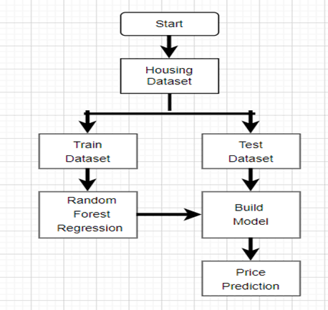

**Program:**

import pandas as pd

import numpy as np

import seaborn as sns

import matplotlib.pyplot as plt

from sklearn.model_selection import train_test_split

from sklearn.preprocessing import StandardScaler

from sklearn.metrics import r2_score,

mean_absolute_error,mean_squared_error

from sklearn.linear_model import LinearRegression

from sklearn.linear_model import Lasso

from sklearn.ensemble import RandomForestRegressor

from sklearn.svm import SVR

import xgboost as xg

%matplotlib inline

import warnings

warnings.filterwarnings("ignore")

/opt/conda/lib/python3.10/site-packages/scipy/__init__.py:146:

UserWarning: A NumPy version >=1.16.5 and <1.23.0 is required for

this version of SciPy (detected version 1.23.5

warnings.warn(f"A NumPy version >={np_minversion} and

<{np_maxversion}"

**Loading Dataset:**

dataset = pd.read_csv('E:/USA_Housing.csv')

**2.Preprocessing the dataset:**

* Data sing is the process of cleaning, transforming, and integrating data in order to make it ready for analysis.
* This may involve removing errors and inconsistencies, handling missing values, transforming the data into a consistent format, and scaling the data to a suitable range.

**Visualisation and Pre-Processing of Data:**

In [1]:

sns.histplot(dataset, x='Price', bins=50, color='y')

Out[1]:

<Axes: xlabel='Price', ylabel='Count'>

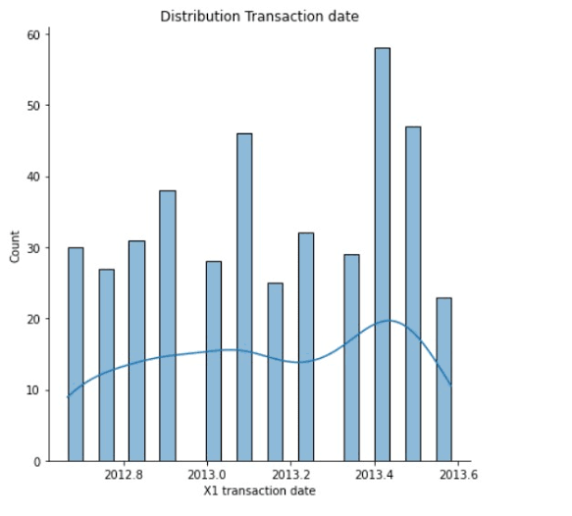

In [2]:

sns.boxplot(dataset, x='Price', palette='Blues')

Out[2]:

<Axes: xlabel='Price'>

In [3]:

sns.jointplot(dataset, x='Avg. Area House Age', y='Price', kind='hex')

Out[3]:

<seaborn.axisgrid.JointGrid at 0x7caf1d571810

In [4]:

sns.jointplot(dataset, x='Avg. Area Income', y='Price')

Out[4]:

<seaborn.axisgrid.JointGrid at 0x7caf1d8bf7f0

In [5]:

plt.figure(figsize=(12,8))sns.pairplot(dataset)

Out[5]:

<seaborn.axisgrid.PairGrid at 0x7caf0c2ac550>

<Figure size 1200x800 with 0 Axes>

In [6]:

dataset.hist(figsize=(10,8))

Out[6]:

array([[<Axes: title={'center': 'Avg. Area Income'}>,

<Axes: title={'center': 'Avg. Area House Age'}>],

[<Axes: title={'center': 'Avg. Area Number of Rooms'}>,

<Axes: title={'center': 'Avg. Area Number of Bedrooms'}>],

[<Axes: title={'center': 'Area Population'}>,

<Axes: title={'center': 'Price'}>]], dtype=object)

**Some common data preprocessing tasks include:**

**Data cleaning**:

This involves identifying and correcting errors and inconsistencies in the data. For example, this may involve

removing duplicate records, correcting typos, and filling in missing values.

**Data transformation:**

This involves converting the data into a format that is suitable for the analysis task. For example, this may involve converting categorical data to numerical data, or scaling the data to a suitable range.

**Feature engineering:**

This involves creating new features from the existing data. For example, this may involve creating features that represent interactions between variables, or features that represent summary statistics of the data.

**Data integration:**

This involves combining data from multiple sources into a single dataset. This may involve resolving inconsistencies in the data, such as different data formats or different variable names.

Data preprocessing is an essential step in many data

science projects. By carefully preprocessing the data, data scientists can improve the accuracy and reliability of their results.

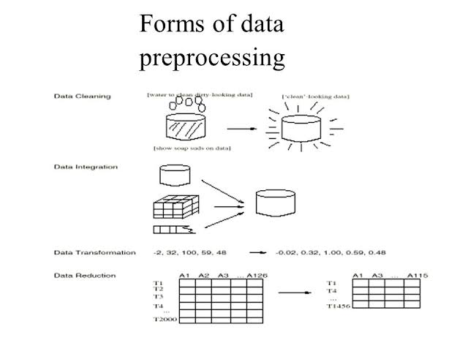

**Program:**

# Importing necessary libraries

import pandas as pd

import numpy as np

from sklearn.model_selection import train_test_split

from sklearn.preprocessing import StandardScaler, OneHotEncoder

from sklearn.compose import ColumnTransformer

from sklearn.pipeline import Pipeline

**# Step 1: Load the dataset**

data = pd.read_csv('E:\USA_Housing.csv')

**# Step 2: Exploratory Data Analysis (EDA)**

print("--- Exploratory Data Analysis ---")

print("1. Checking for Missing Values:")

missing_values = data.isnull().sum()

print(missing_values)

print("\n2. Descriptive Statistics:")

description = data.describe()

print(description)

**# Step 3: Feature Engineering**

print("\n--- Feature Engineering ---")

# Separate features and target variable

X = data.drop('price', axis=1)

y = data['price']

# Define which columns should be one-hot encoded

(categorical)

categorical_cols = [' Avg. Area House Age']

# Define preprocessing steps using ColumnTransformer and Pipeline preprocessor = ColumnTransformer(

transformers=[

('num', StandardScaler(), [' Avg. Area Number of Rooms ', ' Avg.Area Number of Bedrooms ', ' Area Population ', ' Avg. Area Income ']),

('cat', OneHotEncoder(), categorical_cols)

])

**# Step 4: Data Splitting**

print("\n--- Data Splitting ---")

X_train, X_test, y_train, y_test = train_test_split(X, y,

test_size=0.2, random_state=42)

print(f"X_train shape: {X_train.shape}")

print(f"X_test shape: {X_test.shape}")

print(f"y_train shape: {y_train.shape}")

print(f"y_test shape: {y_test.shape}")

**# Step 5: Preprocessing and Feature Scaling using Pipeline**

print("\n--- Feature Scaling ---")

model = Pipeline([

('preprocessor', preprocessor),

])

# Fit the preprocessing pipeline on the training data

X_train = model.fit_transform(X_train)

# Transform the testing data using the fitted pipeline

X_test = model.transform(X_test)

print("--- Preprocessing Complete! ---")

**Output:**

**Exploratory Data Analysis:**

1. **Checking for Missing Values:**

Avg. Area Income 0

Avg. Area House Age 0

Avg. Area Number of Rooms 0

Avg. Area Number of Bedrooms 0

Area Population 0

Price 0

Address 0

**Conclusion:**

* In the quest to build a house price prediction model, we have embarked on a critical journey that begins with loading and preprocessing the dataset. We have traversed through essential steps, starting with importing the necessary libraries to facilitate data manipulation and analysis.
* Understanding the data's structure, characteristics, and any issues through exploratory data analysis (EDA) is

essential for informed decision-making.

* Data preprocessing emerged as a pivotal aspect of this process. It involves cleaning, transforming, and refining the dataset to ensure that it aligns with the requirements of machine learning algorithms.